Find Company Domain Name
On the top right corner click on the “Setup” icon

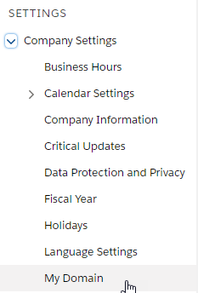
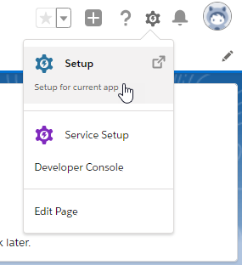
On On the left side pane, search for “Settings” > Company Settings > My Domain

Create a Salesforce Application
Login to Salesforce with an Admin user who can create Applications.

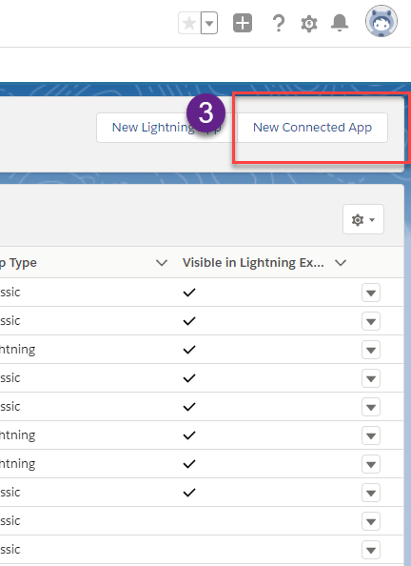
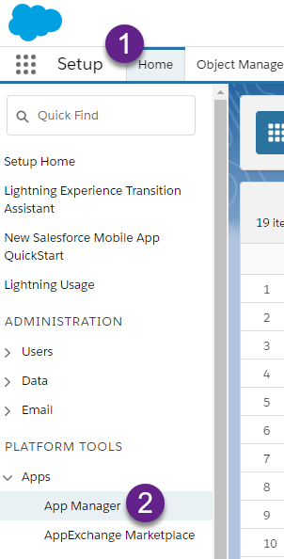
Go to Setup > App Manager > New Connected APP
Use those parameters to set it up:
Basic Information
Connected App Name: SpecterX
Contact Email: support@specterx.com
API (Enable OAuth Settings) - Check
Callback URL:
Selected OAuth Scopes:
- Access and manage your data
- Access your basic information
- Allow access to your unique identifier
- Perform request on your behalf at any time
- Provide access to your data via the web
Require Secret for web Server Flow - Check

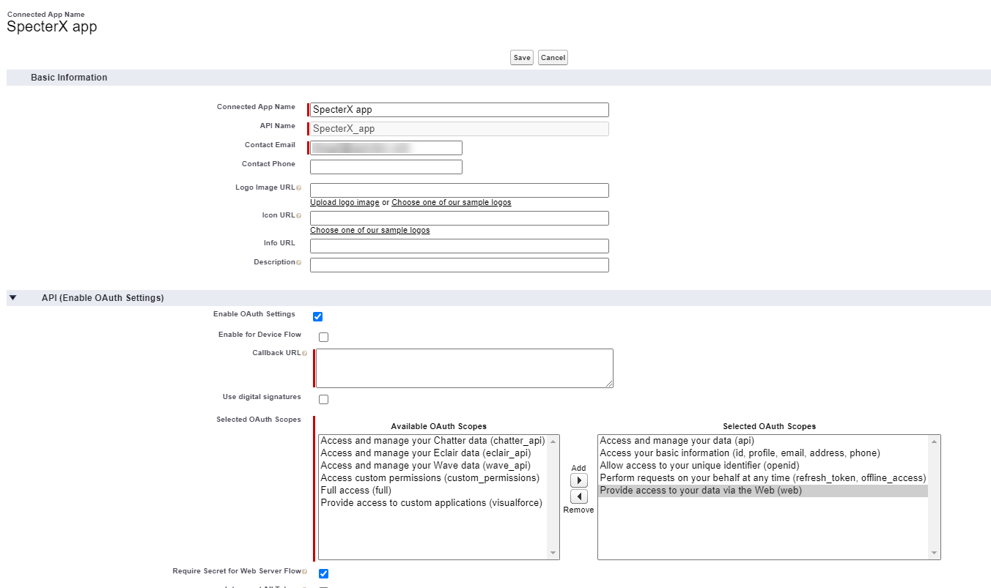
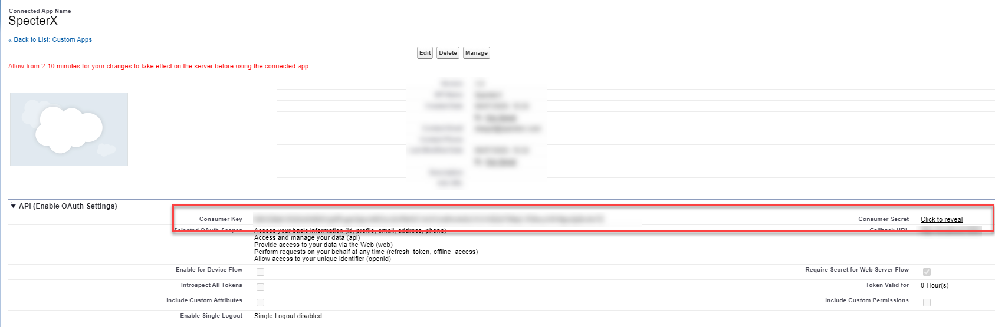

You have created your application, copy customer key, and customer secret and send them to SpecterX

Submit to SpecterX
Finally, log in with and Admin user to SpecterX web application in https://{your-site}.specterx.com

In the left navigation bar click on “Settings” and select “Integrations” tab

Fill in “customer key”, “customer secret” for the SharePoint section and update.

